DATEROEM WOOD SALES
System Documentation
Running and Operating the System
Starting, stopping, checking, publishing and maintaining every server
Document | Running and Operating the System
Document number | DWS-OPS-01
Version | 1.1
Date | 24 October 2026
Intended readers | The business owner and whoever runs the company computer
Classification | Internal - contains system design details; share only with authorised staff
A practical guide to running Dateroem day to day: where everything is, how to start and stop the servers, how the public address works, how to check that each part is healthy, where the logs are, and routine maintenance.

Document control
Version | Date | Change
1.0 | 3 October 2026 | First complete edition, written from the source code as it stood on this date.
1.1 | 3 October 2026 | Added one approved phone per account (admin approval of new phones) and the fingerprint app lock.
1.1 | 4 October 2026 | Customer support mailbox; where Google sign-in's allowed addresses are kept; daily check of support email.
1.1 | 5 October 2026 | Approving computers for the desktop app, handing over the SuperAdmin role, and what to do if the SuperAdmin's computer is lost; the /admin-api public path, building and handing out the shared desktop copy, correcting a username.
1.1 | 7 October 2026 | Anyone can start the servers; only the SuperAdmin can stop them. Who manages the servers after the move. Keeping the Help page questions current. The Help page email form and its App Password.
1.1 | 8 October 2026 | The public address: the Tunnel Router (Caddy) must be running as well as ngrok (8 October incident); the move to a hosted server is in DWS-CFG-03.
1.1 | 17 October 2026 | Routine: the Africa's Talking balance for SMS codes.
1.1 | 18 October 2026 | Starting the servers in the background after a restart; changing the logo in all three apps with one command.
1.1 | 18 October 2026 | The maintenance page while a server is down; the database clean-up before going live.
1.1 | 24 October 2026 | Resetting someone's password, and the idle lock's minutes.
1.1 | 24 October 2026 | Orders near their promised date.
1.1 | 24 October 2026 | Checking staff worker details, and keeping the worker data key.
Keep this document up to date: when a feature, setting or server changes, edit the matching section here and add a line to the table above.
Contents
1 Introduction 4
2 Where things are 5
3 Starting the system 7
3.1 Recommended: the desktop app 7
3.2 Alternative: the launch script 7
3.3 By hand (inside Ubuntu) 7
4 Stopping the system 9
4.1 After the move to a hosting provider 9
5 The public address 10
6 Checking health 12
7 Logs 13
8 Applying changes 14
9 Testing the mobile app 15
10 Routine maintenance 16
11 Desktop access and the SuperAdmin 17
11.1 If the SuperAdmin's only computer is lost 17
11.2 Giving the desktop app to another admin 17
11.3 Correcting a username 17
11.4 Resetting someone's password 17
11.5 The idle lock 18
11.6 Orders near their promised date 18
11.7 Checking worker details 18
12 Network notes for this computer 19

1 Introduction
Everything runs on one company computer: Windows 11 with an Ubuntu Linux environment inside it (WSL). The database and all servers run inside Ubuntu; the desktop app, ngrok and Android tools run on Windows. This guide is for the person who keeps that computer and the system running.

2 Where things are
What | Where
Project (all servers and the website) | \\wsl.localhost\Ubuntu\root\fathersProject (inside Ubuntu: /root/fathersProject)
Android app project | C:\Users\PC\AndroidStudioProjects\DateroemWoodSales
Desktop app | fathersProject\admin_server_control\desktop; Start Menu shortcut "Dateroem Admin Control"
Launch scripts | C:\Scripts\Launch-Dateroem.bat (start everything in terminals), C:\Scripts\Launch-Backend.bat, C:\Scripts\Update-WSLPortProxy.ps1; /root/run_backend.sh and /root/start_backend.sh inside Ubuntu
Product and campaign media | /root/fathersProject/media (products/, campaigns/)
Shared APK | /root/fathersProject/downloads/dateroem-wood-sales.apk
Database backups | /root/fathersProject/db_backups
Public router configuration | /root/fathersProject/Caddyfile
Original business rules | /root/fathersProject/business rules.txt
This documentation | /root/fathersProject/documentation
Customer support email | dateroemwoodsales+support@gmail.com (shown on the website's Help page) - it arrives in the business Gmail, dateroemwoodsales@gmail.com, under the Customers label
Google sign-in settings | Google Cloud Console, project "Dateroem" (owned by the business Gmail): APIs and Services > Credentials, and Google Auth Platform

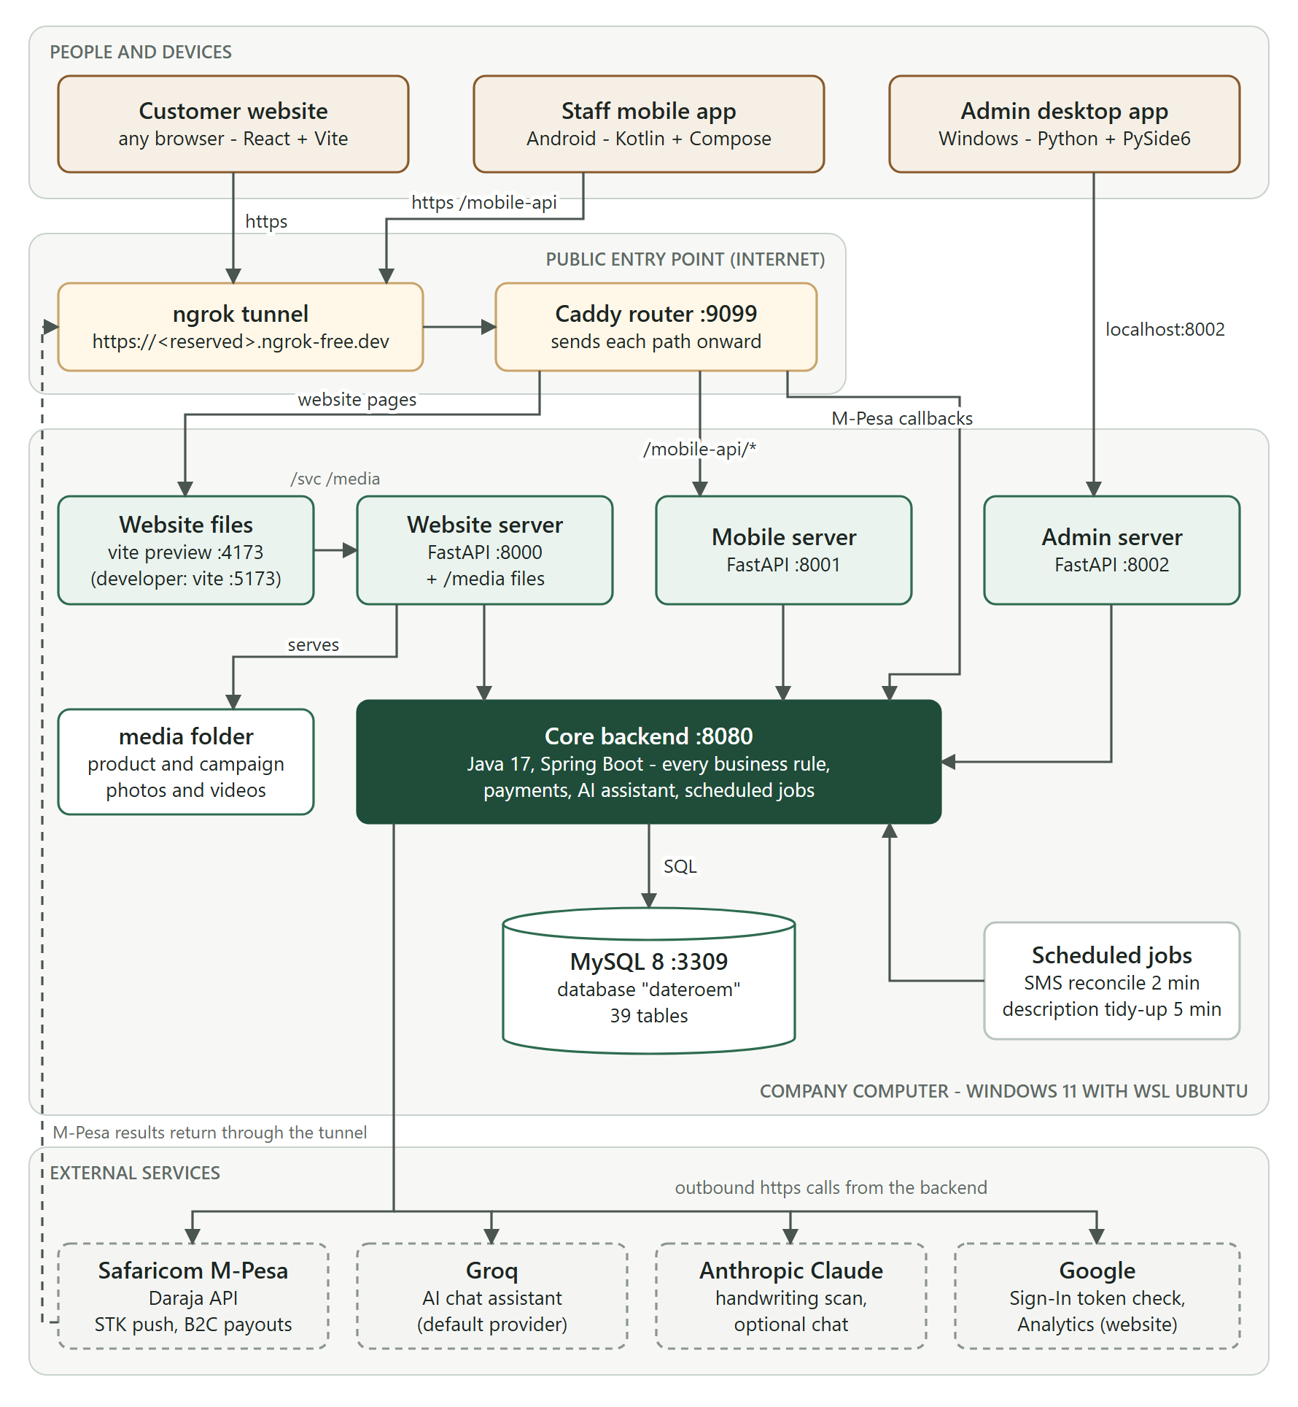
Figure 1: The whole system on one page

3 Starting the system

3.1 Recommended: the desktop app
- Open "Dateroem Admin Control" from the Start Menu.
- On the sign-in window choose the Servers link (or sign in first if the servers are already running, then open the Servers section).
- Press Start All. Each server shows "Starting... N s", then turns to running. The backend can take up to 5 minutes on a first start.
- When everything is running, sign in.

3.2 Alternative: the launch script
Double-click C:\Scripts\Launch-Dateroem.bat. It opens a terminal for each server. Use this only if the desktop app is not available.

3.3 By hand (inside Ubuntu)
service mysql start
/root/run_backend.sh & # backend on 8080 (exports the secrets)
cd /root/fathersProject/frontend && venv/bin/uvicorn app.main:app --host 0.0.0.0 --port 8000 &
cd /root/fathersProject/mobileServer && venv/bin/uvicorn app.main:app --host 0.0.0.0 --port 8001 &
cd /root/fathersProject/admin_server_control/server && venv/bin/uvicorn app.main:app --host 0.0.0.0 --port 8002 &
cd /root/fathersProject/frontend/website && npm run build && npx vite preview --port 4173 &
caddy run --config /root/fathersProject/Caddyfile --adapter caddyfile &
# then on Windows: ngrok http --url <reserved domain> 9099
Server | Port | Needed for
MySQL | 3309 | Everything
Backend (Java) | 8080 | Everything
Website server | 8000 | Website, website images
Mobile server | 8001 | Mobile app, image uploads
Admin server | 8002 | Desktop app
Website dev server | 5173 | Development only
Website public build | 4173 | The public website
Caddy router | 9099 | Anything reached through the internet
ngrok tunnel | (4040 status page) | Public website, shared APK, M-Pesa results

Note: After the computer restarts nothing starts by itself: the website and M-Pesa payments stay offline until the servers are started (on 18 October 2026 they were found stopped after a restart). With nobody at the desktop app, each server can be started in the background from Windows PowerShell - the database with wsl.exe -e bash -c "service mysql start", the backend with Start-Process wsl.exe -ArgumentList '-e','bash','/root/run_backend.sh' -WindowStyle Hidden, then the same with /root/dateroem_start/frontend_bff.sh, mobile_bff.sh, admin_bff.sh, website_public.sh and tunnel_router.sh, and the ngrok tunnel last. Their logs are in /tmp/<name>.log.
While a server behind the router is down, visitors see a "We'll be right back" page (the emblem, a short note and the company number) that reloads by itself when the site is back, and the apps show "We can't reach Dateroem right now" - never an error page (since 18 October 2026; Caddyfile handle_errors, page in deploy/maintenance).
On 18 October 2026 the database was cleaned for going live and everything kept numbered from 1 (see the Database document). The record of every old and new number is db_backups/2026-10-18-cleanup-record.txt. Everyone signs in once more after it.

4 Stopping the system
Sign in as the SuperAdmin, open the Servers section, press Stop All and confirm. Each server shows "Stopping..." until its port is closed. Since 7 October 2026 only the SuperAdmin can stop servers; anyone - signed in or not - can start them, so an honest admin can always bring the system back.
Note: Closing the desktop app on this computer also stops the servers it started (they run inside it). Leave it open, minimised.

4.1 After the move to a hosting provider
The servers will run as services on the provider's machine: they start when it starts and restart themselves if one stops, so nobody needs to start them by hand. Only the SuperAdmin (the owner) stops or restarts them, in the provider's control panel or by remote login, with a strong password and two-factor sign-in. The desktop app shows no Servers panel when its server is not this computer, and it should stay that way. An uptime service that checks the website and /api/health every minute and sends an SMS or email when something is down tells the SuperAdmin at once.
Caution: On this computer service mysql stop fails because the Ubuntu maintenance login is out of date. If MySQL must be stopped by hand, stop it gracefully with kill -TERM $(pidof mysqld) inside Ubuntu. Never use kill -9 on the database.

5 The public address
Customers, admins elsewhere and Safaricom reach the system through one public HTTPS address: a reserved ngrok domain. ngrok runs on Windows and forwards to the Caddy router on port 9099, which decides where each path goes.
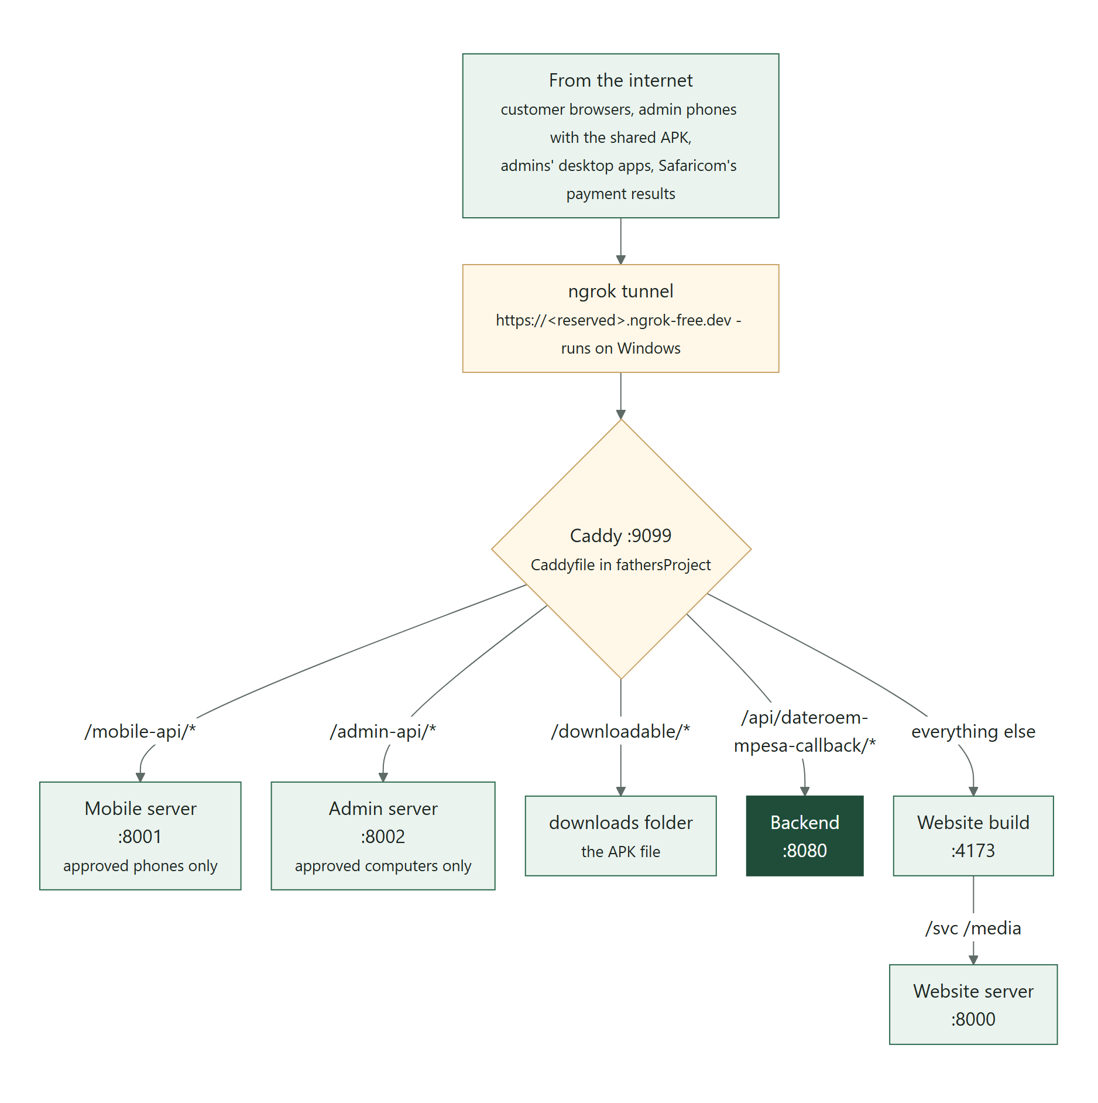
Figure 2: What the public address leads to
- Only five kinds of path are public: website pages, /mobile-api/*, /downloadable/*, /admin-api/* (the desktop app on other computers, since 5 October 2026 - approved computers only, its API pages hidden) and the M-Pesa callback path. The backend's other endpoints are never public.
- The ngrok status page on Windows is http://localhost:4040 (requests, errors).
- The reserved domain is what the M-Pesa callback settings and the shared APK point at. If the domain ever changes, update MPESA_CALLBACK_URL, the B2C result URLs and the Google sign-in authorised origins (Google Cloud Console, project "Dateroem", APIs and Services > Credentials, the web client), and rebuild the shared APK.
- The ngrok account token is stored in ngrok's own configuration on Windows, not in the project.

Tip: For production the system moves to a rented server under the company domain, where Caddy obtains HTTPS certificates itself and the paths stay the same. The Hosting and Deployment Guide (DWS-CFG-03) and the deploy/ folder cover it: where to host, the domain, the move step by step, running the server (services, logs, backups) and every value to change.
Caution: ngrok can be up while the Tunnel Router (Caddy) is not - then every public request fails although the website works on this computer (8 October 2026, after an internet drop). After any restart or internet drop, check that "Tunnel Router (Caddy)" shows as running in the Servers section.

6 Checking health
Check | How | Expected
All servers | Desktop Servers section | Every dot green (running)
Backend and database | curl http://127.0.0.1:8080/api/health | "status": "ok", "db": "connected"
Website server | curl http://127.0.0.1:8000/health | status ok
Mobile server | curl http://127.0.0.1:8001/health | status ok
Admin server | curl http://127.0.0.1:8002/health | status ok
AI assistant | curl http://127.0.0.1:8080/api/ai/chat/status | "available": true
Public website | Open the public address in a phone browser | Products page loads with photos
Public app path | https://<public domain>/mobile-api/health | status ok
Tunnel | http://localhost:4040 on Windows | Tunnel online, recent requests listed

7 Logs
Component | Where to read it
Any server started by the desktop app | Servers section, that server's tab (secrets masked)
Backend started by run_backend.sh | /tmp/backend-r9.log inside Ubuntu
Backend payment problems | Search the backend log for "Daraja" or "STK"
Older router and tunnel runs | fathersProject/caddy.log and ngrok.log
Mobile app | Android Studio Logcat (OkHttp lines show each request)

8 Applying changes
Changed | What to do
Backend Java code or application.properties | Restart "Backend (Java)" in the Servers section (or mvn -q compile while it runs, which restarts it)
A secret or environment variable | Update the launch scripts and server_manager.py, then restart the backend
Python server code | Nothing - they reload automatically (--reload)
Website code | Development server updates live; for the public site restart "Website (public build)" (it rebuilds)
Website .env | Restart the public build (values are read at build time)
Mobile app | Test on the USB phone, then rebuild and replace the shared APK
Desktop app | Close and reopen it, then sign in again
Caddyfile | Restart "Tunnel Router (Caddy)"

9 Testing the mobile app
- Connect the test phone by USB (USB debugging on).
- The Servers panel re-applies adb reverse tcp:8001 tcp:8001; otherwise run it from C:\Users\PC\AppData\Local\Android\Sdk\platform-tools.
- Install the debug build from Android Studio and test.
- Only after the change works on USB, rebuild the shared APK with the public address and replace the file in the downloads folder (see DWS-MOB-02).

10 Routine maintenance
How often | Task
Daily | Check all servers are green; look at unassigned transactions and pending refunds; confirm the tunnel is online; answer new customer emails under the Customers label in the business Gmail
Weekly | Back up the database (see DWS-BE-02) and copy the file off the computer; check free disk space; review the backend log for payment errors; glance at Users > Phones (nothing should be waiting that nobody expects)
Monthly | Install Windows and Ubuntu updates (then restart and Start All); review user accounts and disable people who left
When the business Gmail password changes | Google cancels the App Password the Help page form sends with. Create a new one (Google Account, Security, App passwords), replace SMTP_APP_PASSWORD in frontend/.env and restart Frontend BFF; send yourself a test from the Help page
When a feature changes | Update the questions it affects in the desktop app, FAQs, so the website's Help page stays right (untick "Show on the website" to take one off for a while)
Monthly, or when codes stop arriving | Check the Africa's Talking balance (SMS codes for phone numbers) and top up by M-Pesa Paybill 525900 with the account number shown on its top-up page. When it runs out, codes pause by themselves and customers carry on without one; the backend log says "phone codes paused".
When the logo changes | Change it only in frontend/website/src/brand/emblem.js, then run npm run brand:export -- --mobile <phone project>/app/src/main/res (inside Ubuntu, in frontend/website): it writes the website's icons, the business pictures, the desktop app's icon and emblem and the phone app's icon and emblem. Rebuild the website and the phone app afterwards.
When staff change | Disable their account in the desktop Users section; change any shared passwords they knew
When a phone is replaced, lost or reinstalled | The SuperAdmin, in Users > Phones in the desktop app: approve the new phone with replace after checking the model with the person; block a lost or stolen phone at once
When an admin gets a new computer, or one is lost | The SuperAdmin, in Users > Computers: approve the new computer (with replace if the account already has one) after checking the name the person sees on their sign-in screen; block a lost, stolen or given-away computer at once
Every 30 days | Users are asked to sign in again (sign-in tokens last 720 hours; desktop sign-ins last 12 hours)

11 Desktop access and the SuperAdmin
Since 5 October 2026 the desktop app signs in only on approved computers, and only the one SuperAdmin (sadmin) approves computers and phones (see the Desktop Admin Application document, Signing in from any computer).
- First sign-in after the update. Sign in as the SuperAdmin first on the owner's computer: the SuperAdmin's first computer is approved automatically. Then each Admin signs in on their own computer, sees "This computer is waiting for approval", and the SuperAdmin approves it in Users > Computers.
- Handing over the SuperAdmin role. In Users > Normal Users the SuperAdmin selects the new person's account and presses Make SuperAdmin. That account becomes the SuperAdmin and the old one an Admin, in one step.
- Wrong passwords. After 5 wrong passwords in 15 minutes the account waits from that address; restarting the admin server clears the count at once.

11.1 If the SuperAdmin's only computer is lost
Nobody else can approve a computer, so this is done once on the server, inside Ubuntu, by someone with database access. First let the SuperAdmin sign in on the new computer so it is listed as waiting, then approve that row and block the lost one:
mysql -h 127.0.0.1 -P 3309 -u dateroem_backend -p dateroem

SELECT Computer_ID, Computer_Name, Status FROM USER_COMPUTERS WHERE User_ID = 11;
UPDATE USER_COMPUTERS SET Status = 'REVOKED', Revoked_At = NOW() WHERE Computer_ID = <lost one>;
UPDATE USER_COMPUTERS SET Status = 'ACTIVE', Approved_By = 11, Approved_At = NOW() WHERE Computer_ID = <new one>;
Note: User 11 is sadmin, the SuperAdmin on 5 October 2026; use the current SuperAdmin's id if the role has been handed over.

11.2 Giving the desktop app to another admin
Hand over admin_server_control\desktop\dist\Dateroem Admin Control 1.1.zip. The admin unzips it, opens Dateroem Admin Control.exe, signs in and sees that the computer is waiting; approve it in Users > Computers. The copy starts at the public tunnel address (/admin-api), so this computer, the servers and the tunnel must be running for them to work. To make a new zip (after app changes, or with the provider's address after the move), run inside admin_server_control\desktop:
venv\Scripts\python.exe build_shared_copy.py https://<public address>/admin-api

11.3 Correcting a username
If an account was made with a wrong username, the SuperAdmin selects it in Users > Normal Users, presses Edit and changes the Username field. The person signs in with the new username from then on; their sign-in, phone and computer approvals stay as they were.

11.4 Resetting someone's password
Nobody can see a password, not even the SuperAdmin. If someone forgot theirs: Users > Normal Users, select the account, Reset Password, confirm, and give them the temporary password shown - in person or by phone, never in a group chat. They are signed out everywhere, and at their next sign-in (website, phone or desktop) they must choose a password of their own before anything else. Only the SuperAdmin resets an Admin; the SuperAdmin changes their own from Profile.

11.5 The idle lock
The desktop and phone apps lock after 25 minutes untouched (the desktop asks for the password, the phone for the fingerprint), with Still there? a minute before. The SuperAdmin changes the minutes (5 to 120) in the desktop app: Settings > Idle lock. Other computers and phones take the new value at their next sign-in or start.

11.6 Orders near their promised date
Check Insights > Orders (desktop) or Orders (phone) daily. Orange orders are close to the date the customer was promised and red ones are past it - put them on a delivery that arrives by then, red first. Admins see the counts on the phone's Home too.

11.7 Checking worker details
Staff fill in their worker details in the phone app (My profile > Worker details). In the desktop app, Users > Worker Details shows who is Waiting for checking. The SuperAdmin selects the person, Open Details, compares the numbers with the photos (View Photo), and presses Mark Verified - or Send Back... saying what to fix (the person sees the note on their phone). Each opening is written to the audit log; don't copy the numbers or photos anywhere else. When someone leaves, the details stay until the SuperAdmin presses Delete All Details.
The details are encrypted with the worker data key (app.workers.data-secret in the backend's application.properties). Keep a second copy of that file, or of that one line, away from this computer with the owner: if the key is lost, the details and photos can never be read again, even from a database backup.

12 Network notes for this computer
- MySQL runs on port 3309 because something outside the project keeps a phantom listener on 3306.
- Windows reaches the servers inside Ubuntu through WSL's port forwarding. If Windows tools suddenly cannot reach a running server, restart WSL (wsl --shutdown, then start again) or run C:\Scripts\Update-WSLPortProxy.ps1 as administrator.
- Java is forced to IPv4 and the website proxy uses 127.0.0.1 instead of "localhost", because "localhost" sometimes resolved to an unreachable IPv6 address here.
- Some external services (Safaricom, Groq) occasionally resolve to dead addresses from this network; the backend retries safely.

